FizzBuzz
Platform: HackerRank
Language: C
Module 2, Question 5

Problem Link
https://www.hackerrank.com/challenges/fizzbuzz/problem

Problem Statement
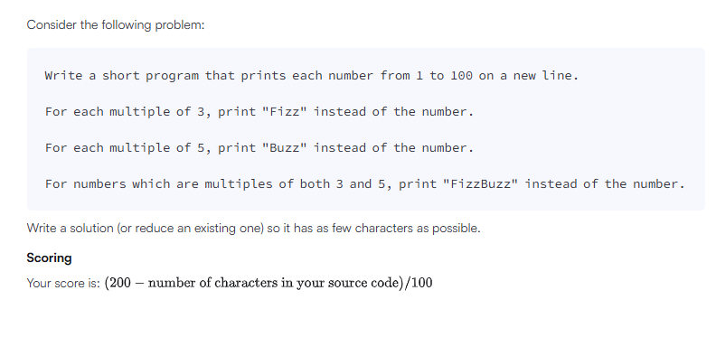

C Code
#include <stdio.h>

int main() {
for (int i = 1; i <= 100; i++) {
if (i % 15 == 0)
printf("FizzBuzz\n");
else if (i % 3 == 0)
printf("Fizz\n");
else if (i % 5 == 0)
printf("Buzz\n");
else
printf("%d\n", i);
}
return 0;
}

Screenshot of Successful Submission



